**Monolithic:**

* Monolith means composed all in one piece.
* The Monolithic application describes a single-tiered software application in which different components combined into a single program from a single platform

Components can be:

* **Authorization** —responsible for authorizing a user
* **Presentation** —responsible for handling HTTP requests and responding with either HTML or JSON/XML (for web services APIs).
* **Business** **logic** —the application’s business logic.
* **Database** **layer** —data access objects responsible for accessing the database.
* **Application** **integration** —integration with other services (e.g. via messaging or REST API). Or integration with any other Data sources.
* **Notification** **module** —responsible for sending email notifications whenever needed.

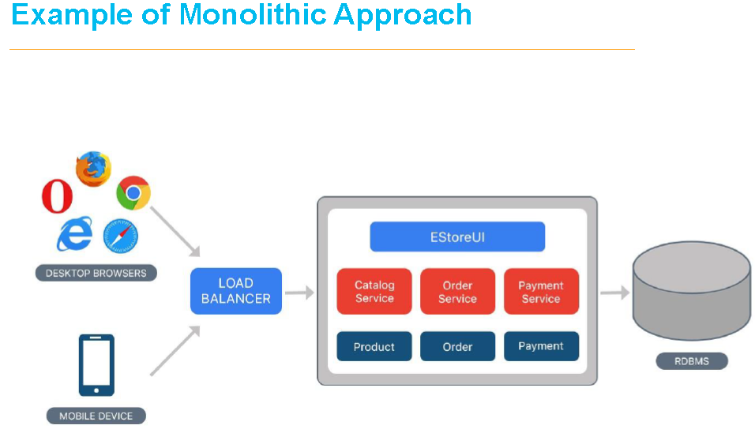

**Drawbacks**

* Maintenance —If Application is too large and complex to understand entirely, it is challenging to make changes fast and correctly.
* The size of the application can slow down the start-up time.
* You must redeploy the entire application on each update.
* Monolithic applications can also be challenging to scale when different modules have conflicting resource requirements.
* Reliability —Bug in any module (e.g. memory leak) can potentially bring down the entire process.
* Moreover, since all instances of the application are identical, that bug impact the availability of the entire application
* Regardless of how easy the initial stages may seem, Monolithic applications have difficulty to adopting new and advance technologies.
* Since changes in languages or frameworks affect an entire application.
* It requires efforts to thoroughly work with the app details.
* Hence it is costly considering both time and efforts.

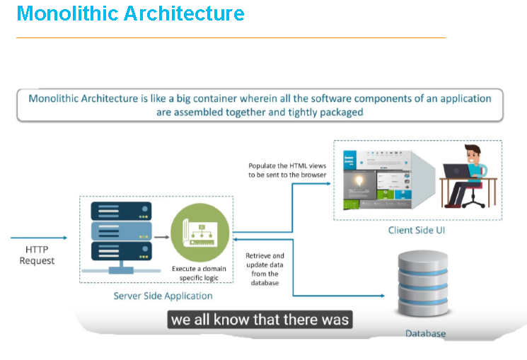

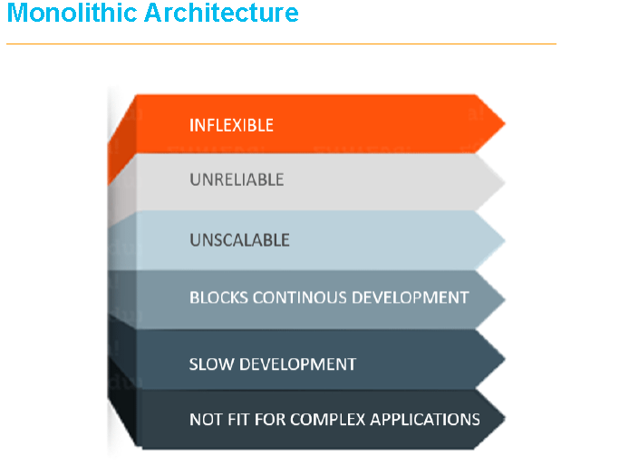

**Micro Service:**

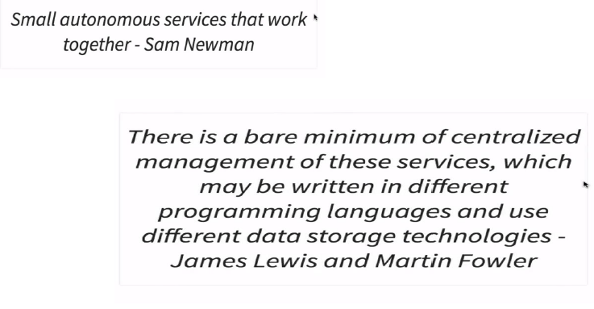

**Goals**

* Independent deployment of components
* Independent scaling of components
* Independent implementation stacks for each component
* Easy self-serve deployments of components
* Repeatable deployments of components (external configuration management)
* Deployments without service interruptions
* Protection of system availability from individual Instance failure
* Automatic replacement of component instances when they fail (self-healing)
* Easy scaling of components by adjusting a simple parameter value

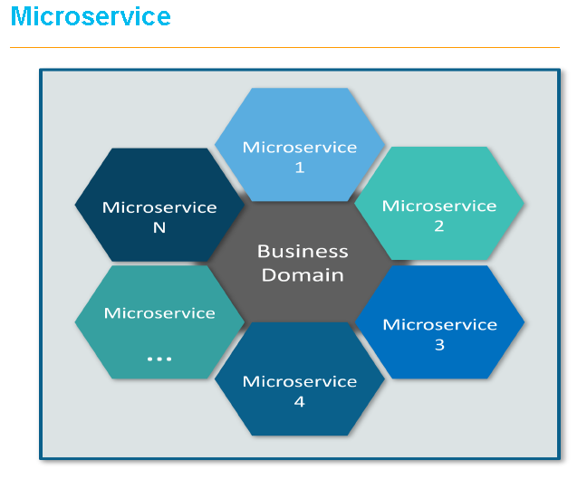















**What is Microservice?**

* Microservices is a variant of the service-oriented architecture (SOA) architectural style that structures an application as a collection of loosely coupled services.
* In micro services architecture, services should be fine-grained and the protocols should be lightweight.
* The benefit of decomposing an application into different smaller services is that it improves modularity and makes the application easier to understand, develop and test.
* It also parallelizes development by enabling small autonomous teams to develop, deploy and scale their respective services independently.

**UBER CASE STUDY**

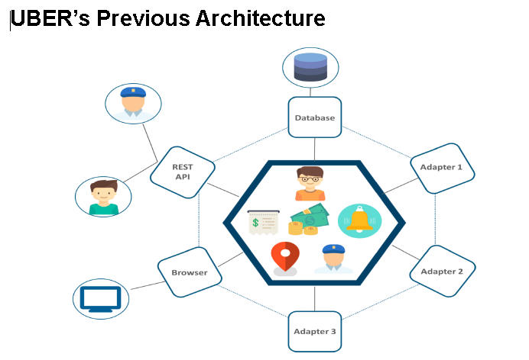

**With Micro Service**:

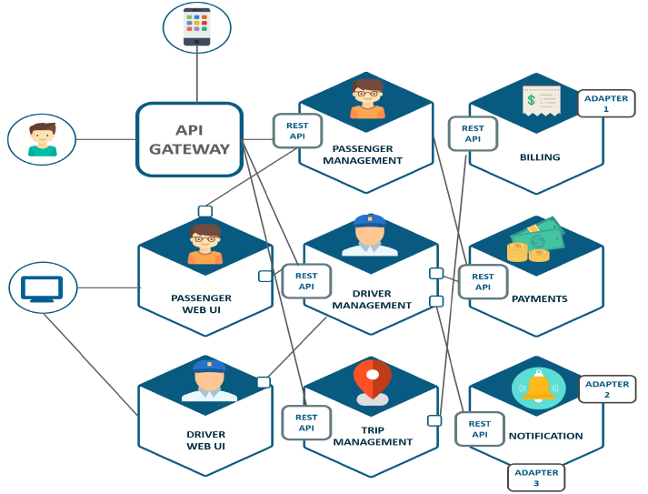

**Principles of Micro service**

* Independent & Autonomous Services
* Scalability
* Decentralization
* Resilient Services
* Real-Time Load Balancing
* Availability
* Continuous delivery through DevOps Integration
* Seamless API Integration and Continuous Monitoring
* Isolation from Failures
* Auto -Provisioning

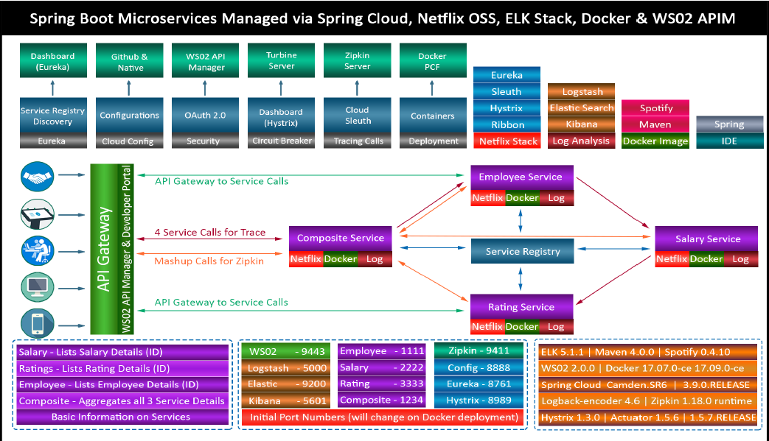

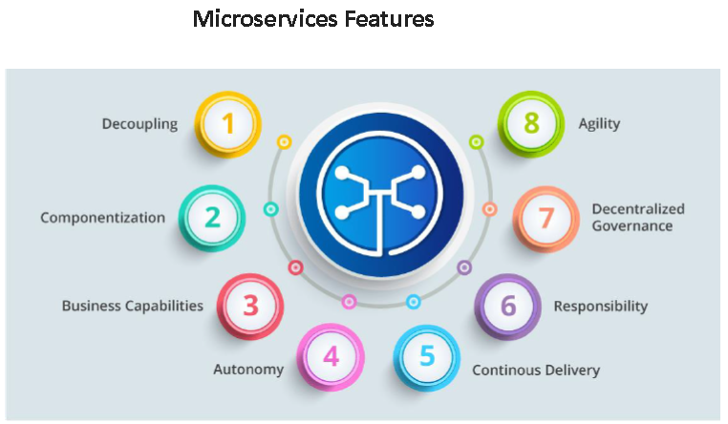

**Advantages of Microservices**



**Best Practices to Design Microservices**

